# 3D Animation and Visualisation 2020

# **Up High: building a low poly scene**

This project showcases the usage of basic elements and techniques

essential to achieve a low poly interactable render/application.

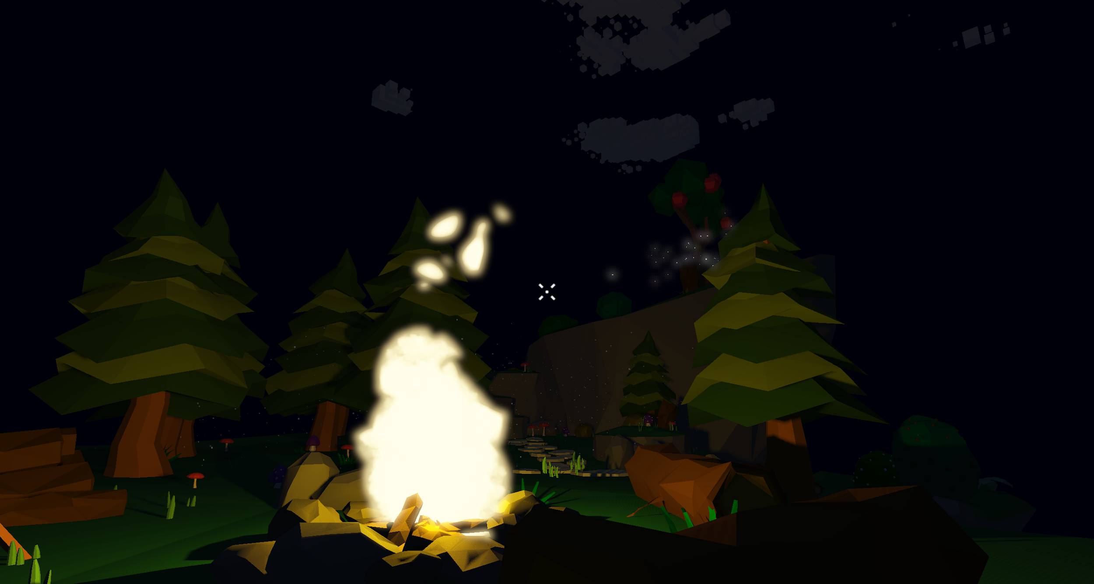

*Fig 1 - Project Snapshot*

|  |  |  |  |
| --- | --- | --- | --- |
| **Alexandre Duarte**  89403  MEIC - AVT 2020/21  alexandre.a.duarte@tecnico.ulisboa.pt | **David Brás**  89432  MEIC - AVT  2020/21  david.bras  @tecnico.ulisboa.pt | **Inês Correia**  89464  MEIC - AVT 2020/21  inesmargarida1618@tecnico.ulisboa.pt | **Andreia Matos**  89413  MEIC - AVT  2020/21  andreianmatos  @tecnico.ulisboa.pt |

**Abstract**

This paper describes basic graphical techniques and challenges, along with their practical implementation and integration, in the context of creating a low poly render with some interactable components. For this effect we aimed to mix the primitive solid geometry characteristic of the low poly style, with the more dynamic properties accomplished by particle elements.

Effectively, the final application is the result of integrating the following components: non-physically based “photorealistic” Blinn-Phong lighting model using directional light and point light; Generation of shadows accomplished with shadow mapping using texture targets to store depth buffer information of the scene; Particle simulations resembling environment dust, fireflies and stylised fire, using instanced rendering; Post-processing bloom effect with HDR; Mouse-object interaction using the stencil buffer; Generic scene graph architecture capable of supporting multiple node types with varied drawing techniques.

The geometry elements populating the scene were modeled in Blender and exported as Wavefront (.obj) including colored faces and then imported by the application and integrated in the scene graph.

## **Concept**

In our early stages looking into concepts, we first investigated the possibility of creating astructure similar to a snow globe, containing an interactive scene. 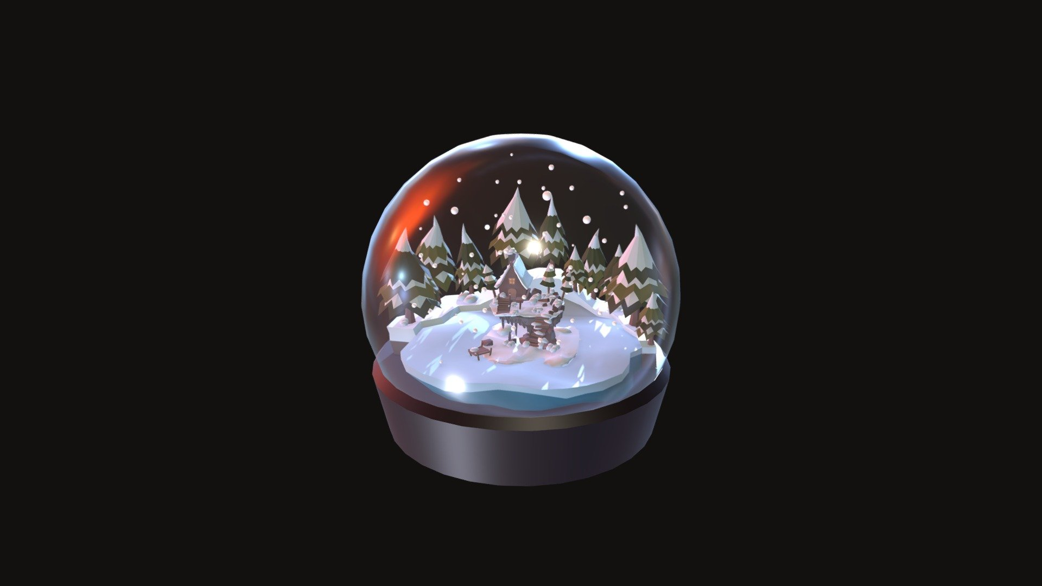

*Fig 2 - Snow Globe modelled scene*

However, our initial search for techniques to follow through with it lacked promising results, which led us to slightly alter our idea for the project.   
  
 It was also set that it would be a low-poly scene, due to our fondness for the aesthetic and we decided we would later decide on the suiting techniques to better enhance its appearance.   
 While searching for alternatives, we found various low poly minimalistic scenes depicting magical environments that featured objects such as fireflies and giant mushrooms, which led us to realize the various opportunities that such scenes encompassed for the employment of some of the techniques we wanted to achieve. 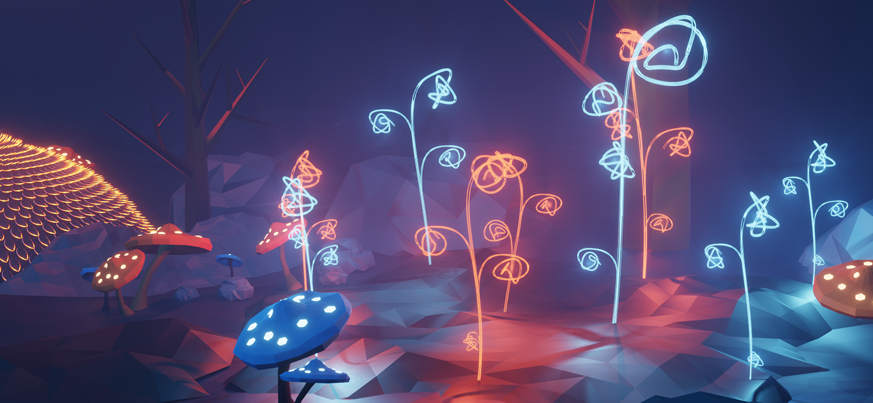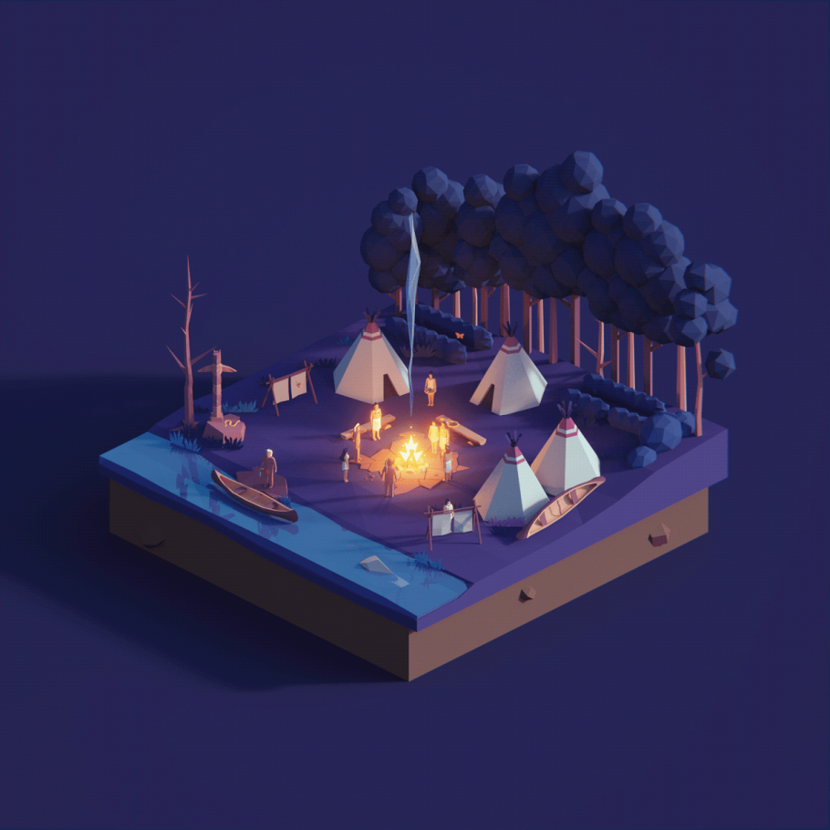

*Fig 3,4 - Examples of the magical forest environments that inspired us*

We set out to create an environment that contained stylized animated fire simulation, floating dust/pore-like particles to create ambiance and procedurally generated solid low poly clouds, amongst other elements. Besides that, we also decided that the scene would have some interactable events using the mouse on predetermined target objects.  
 From these ideas we then decided on the main technical challenges that we would take on for this project, them being:

1. Generic Scene Graph
2. Mouse-object Interaction
3. Blinn-Phong
4. Bloom Effect
5. Stylised Procedurally Generated Clouds
6. Shadows
7. Particle System

Throughout the project we made adjustments to our idea in order to display the technical challenges implemented in the best possible way along with the visuals of the scene.

## **Technical Challenges (max 1 page / student)**

## **Generic Scene Graph** [all members]

We decided to use a Generic Scene Graph to organize our project as the hierarchy of the elements made it easier to perform some transformations as it also benefited the rendering and just altogether kept the project much more organized.

## **Mouse-Object Interaction** [Inês Correia, resulting interactions: all members]

Because of our plan of making a scene composed with various elements we thought from the beginning that it would be nice to implement a way to interact with them. The more straightforward and easy way of interaction with objects on a screen is with using a mouse since you can point to what you want to focus on.

In order to attain mouse-object interaction we needed to implement the “picking” of objects, handle mouse events and create the consequent effects on the scene.

## **Non-Physically based “photorealistic” lighting: Blinn-Phong** [David Brás]

Our project was heavily centered around the lighting aspect, and for it to look good, we needed the basics of a shading model. Using Blinn-Phong with the face normals of our models would provide a good base to add the other post processing and shading effects we were after. We needed a point light for a campfire, and a directional light to represent the sun and moon, and combined they would set the tone of our scene.

*Fig 5 - Example of scene with Blinn-Phong* 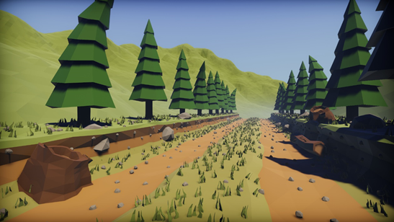

## **Post-processing: Bloom** [Andreia Matos, Inês Correia]

As we intended for our scene to portray a forest, particularly with the night time option, it was important for us to be able to create an interesting dynamic using some bright light sources. One way we found to set these regions apart by their brightness was by making them glow , in particular by implementing the so-called Bloom effect, creating the illusion of light intensity as the radiance spreads across the surrounding pixels of the source.

We took inspiration from other low-poly scenes that also used Bloom to boost the lighting of the scene, which we found produced compelling effects.

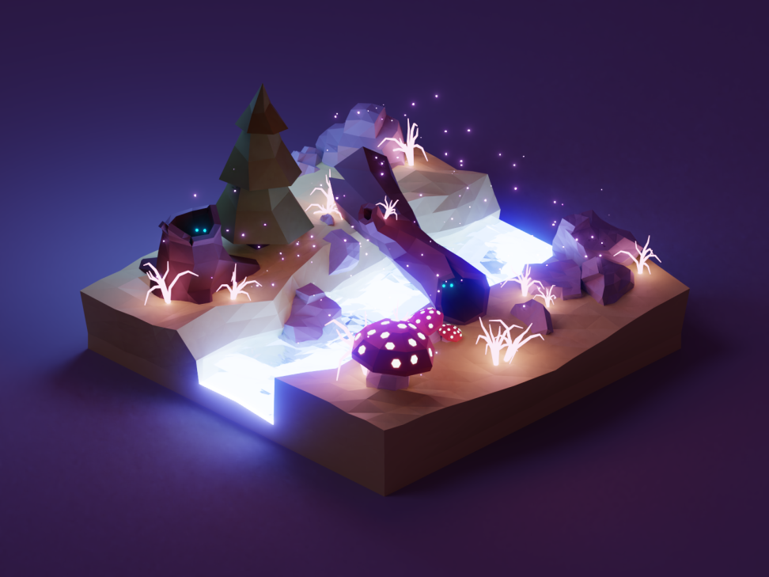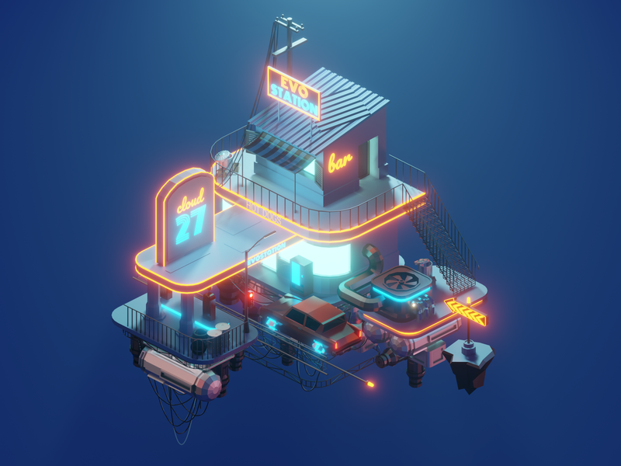

*Fig 6,7 - Inspiration for Bloom*

In order to achieve this desired result, we needed to tackle various challenges, starting with the creation of the necessary frame buffer system to allow for post-processing effects, followed by the implementation of High Dynamic Range (HDR) rendering which makes Bloom more effective and then, finally implement Bloom.

## **Stylized Solid Material: Clouds** [Andreia Matos, Alexandre Duarte]

To complement the scene we decide to implement a cloud system filling the sky above the modeled island.

The task of cloud generation can be divided into 3 main problems that need to be addressed for the cloud system to have a certain degree of realism:

1. Singular cloud creation with an organic look, using procedural generation of the cloud shape.
2. Inter-cloud correlation and mixing such that the cloud filling ratio looks natural and the collision between clouds is seamless.
3. Cloud life cycle, including birth, movement, and vanishement, in a way that doesn’t look disruptive or predetermined.

Additionally given the artistic direction of the project (low poly design), the cloud style needed to be tailored accordingly. Thus, the implemented clouds need to be composed of actual solid geometric elements instead of the usual translucent textured look.

*Fig 8, 9 - Examples of Low-Poly Clouds*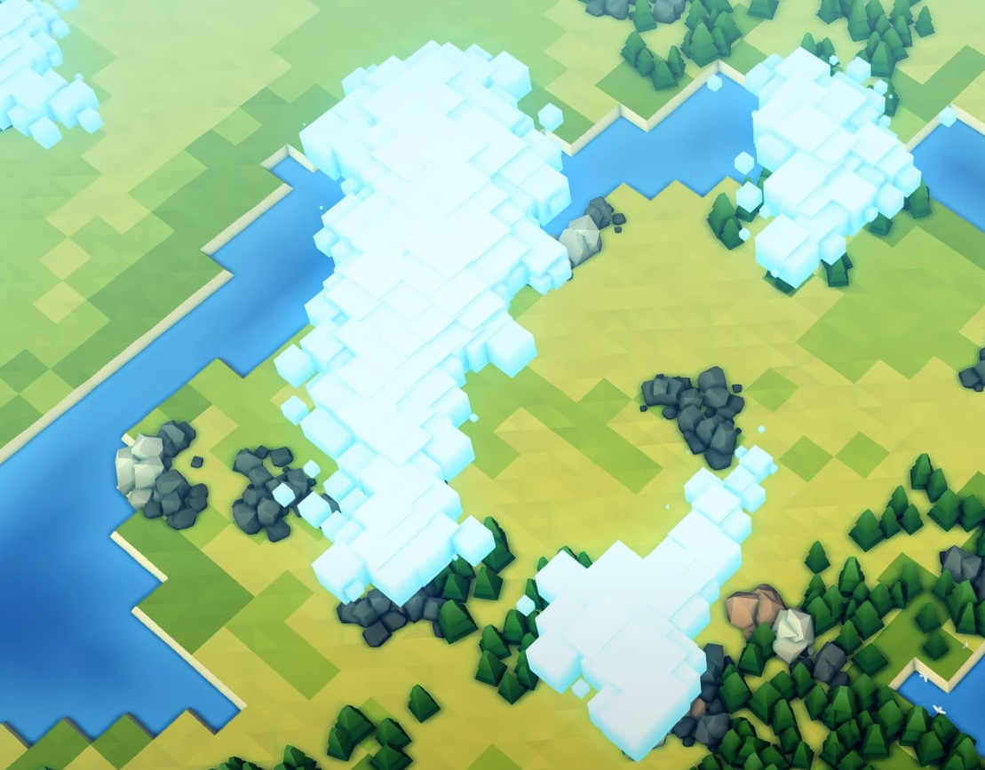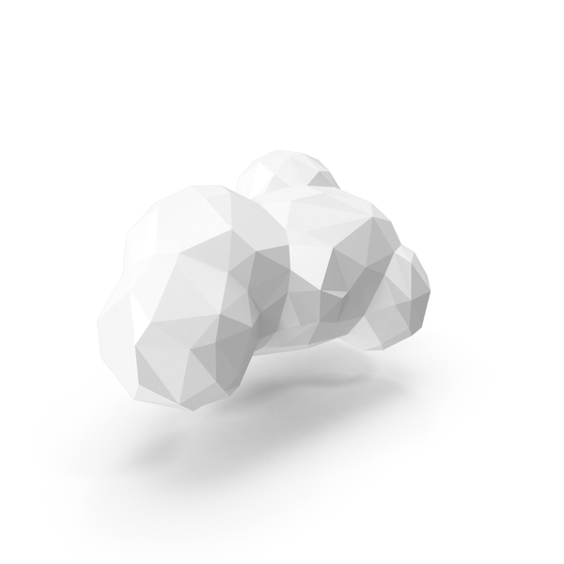

This alternate approach remains in accordance with the 3 step process mentioned but includes the additional challenge of ensuring that the cloud geometry generated still looks organic even given its solid nature.

## **Shadows** [David Brás]

Despite being a low poly scene, we still wanted our lighting to look plausible, and shadows would go a long way to add depth and contrast to the scene. To achieve this, we used Shadow Mapping to apply to the lighting in our scene. To accomplish this, some cameras looking in the light direction need to render depth information to a texture, and this texture is used to check if a certain fragment is shadowed or not.

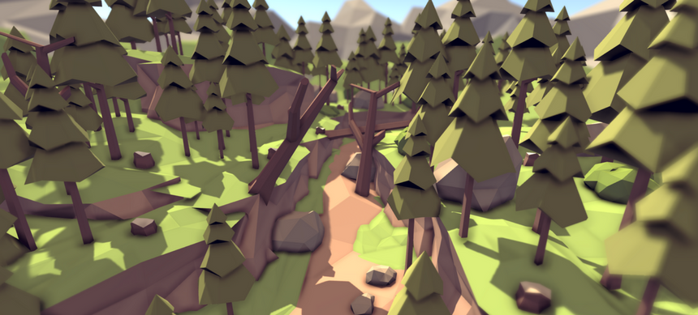

*Fig 10 - Example of Shadows*

## **Particle System** [Alexandre Duarte]

The desired final scene includes 3 elements accomplished using particle systems: environment dust, firefly-like flying entities, and fire.

As such, this requires primarily the creation of a general-purpose particle emitter entity capable of handling both the cpu and gpu side support essential to render particles.

On the cpu-side the emitter must provide 2 resources:

1. Storage structures and underlying access mechanisms needed to manage large amounts of particles efficiently;
2. Template behavior structure for recurrent particle initiation, spawning, update, and death.

To fulfill the gpu-side support the emitter must be accompanied by:

* A vertex shader responsible for ensuring the particles are always rendered facing the camera all the while respecting the scene graph transformation.
* A fragment shader that supports texture application and basic coloring.

Additionally, as most particle effects deal with some degree of partial transparency, the emitter must handle the correct render of the particles taking into consideration multiple and simultaneous transparency overlays.

Having the described emitter implemented, the 3 particle effects mentioned are created by adapting the template behaviour structure and possibly the shaders.

For the dust and fireflies the adaptation is straightforward, on the other the fire simulation desired is a variant fitting the project art style, meaning it should have a more animation-like look rather than realistic look. Thus, its implementation requires more advanced variations specifically to the shaders.

*Fig 11 - Fire Particle System*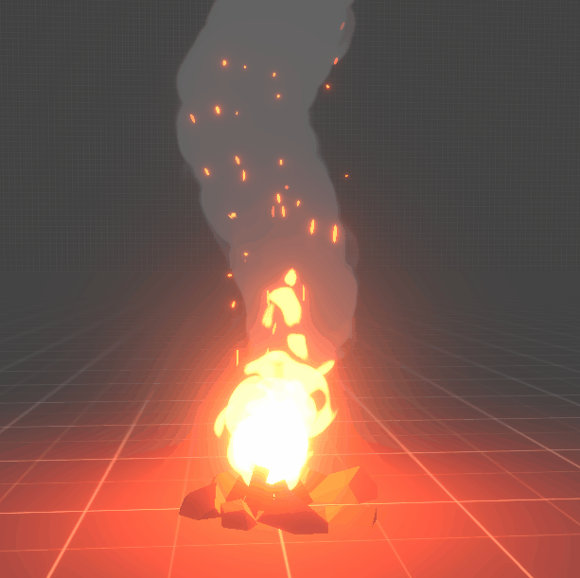

## **Additional Techniques**

## **HUD Element: Crosshair** [Alexandre Duarte]

Along the development process we notice that the mouse-object interaction was lacking when controlling the camera in free move mode (meaning the cursor isn’t visible but the movement control is kept).

To improve the experience we determined that additional visual aid was needed in such a way that the user can clearly see where exactly he/she is clicking and which scene object can be interacted with. The solution was the implementation of the well-known crosshair sprite, drawn as a HUD element, always positioned at the center of the window.

## **Background** [Alexandre Duarte]

After the implementation of the bloom post-process effect we noticed the window “clear color” needed to be black in otherwise the background color would bleed towards the drawn elements.

So to solve this problem, and to avoid implementing more advanced background techniques, we decided to use a skybox simplification, using colored quad always filling the viewport and rendered behind all the other scene elements.

* + 1. **Scene Modelling**   
       [Andreia Matos, Inês Correia]

It was an important aspect of our conception for the scene, that it would be a low-poly scene, that is that it would be made up of polygon meshes with a relatively small number of polygons. It was also set that the scene would be a forest so we needed to create a range of forest-themed objects in order to create a rich environment.

We had previously seen various examples of such modelled scenes, as well as various objects within them, that certainly influenced us when creating our own.

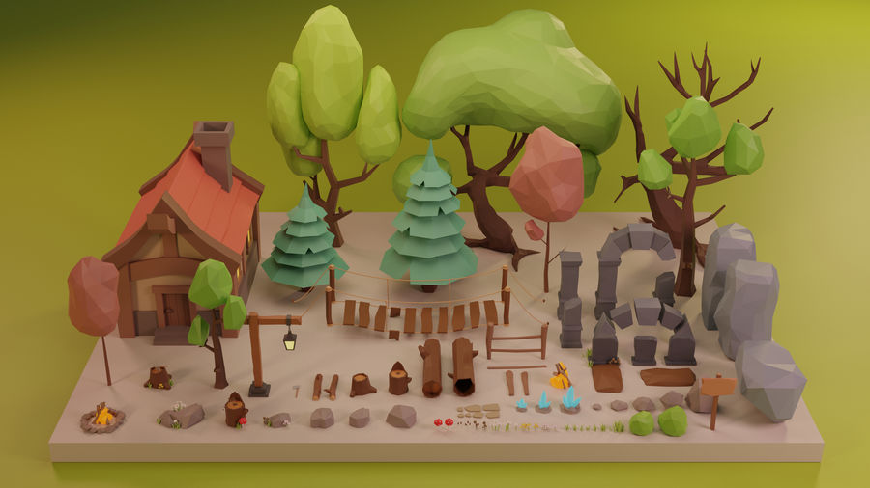

*Fig 12 - Examples of Low-Poly Forest Themed Objects*

## **Proposed Solutions**

## **Generic Scene Graph**

## Explored approaches

For the scene graph, we already had a starting implementation from the previous project, so we ended up expanding on that solution.

## Final implementation

The scene is composed of Scene Nodes, each of the nodes containing information about:

- The parent node.

- The mesh that it represents, if any.

- The transformation matrices that are applied to it (translation, rotation, and scale)

- The shader that is used to draw the mesh.

- And the callback that is applied before and after the visit to the scene node.

This information is then used to appropriately draw each one of the objects on the scene. The transformation matrices are used in conjunction with the parent matrices, in order to correctly draw the mesh in its correct position, and have the parent influence the child node. The specified mesh and shader are used in the draw call, which allows us to personalize how each node is rendered, and the callbacks are used in case we want to change some OpenGL settings for the specific draw call, for example, disabling face culling only for that specific node.

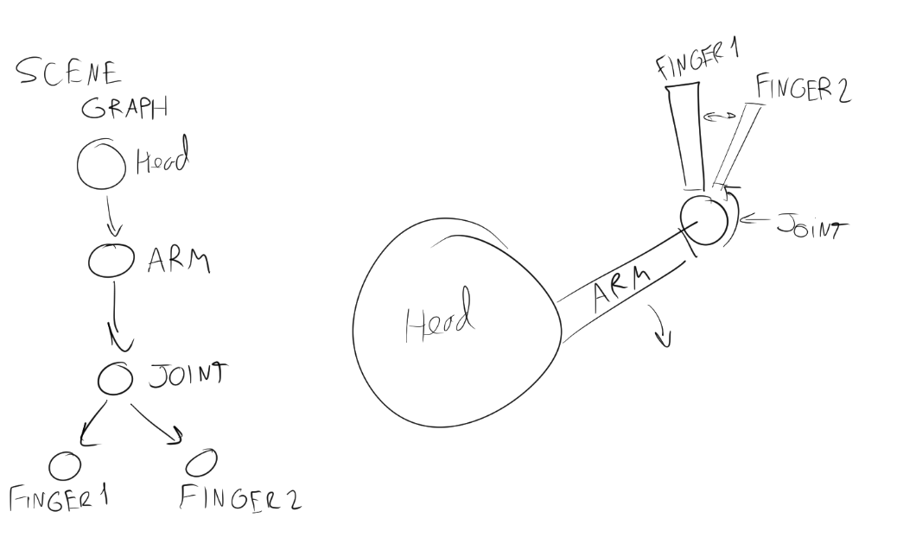

## **Mouse-Object Interaction**

## Explored approaches

We wanted to click and interact with 3D objects in our scene using the mouse cursor. Our first approach to this involved casting a 3D ray from the mouse, through the camera, into the scene, and then check if that ray intersects with any object. However, this method uses bounding boxes or bounding spheres and we realized that would not work with very irregularly shaped objects and also, would be impossible to obtain total accuracy.

Therefore, we wanted a method that would outline the shape of the object more precisely and that would not permit ambiguous selections. We opted to use the stencil testing that let us do exactly that.

## Final implementation

The stencil test happens after the fragment shader has processed the fragment and it gives the possibility to discard that fragment. The stencil test is based on the content of a modifiable buffer called stencil buffer that can be changed during rendering.

When the stencil buffer is cleared all his values are set to zeros and using stencil buffer operations we can set specific values to certain fragments at the time of rendering, each stencil value has 8 bits of memory reserved for it and that amounts to a total of 256 possible stencil values per pixel. For this reason, if we change the value of the stencil buffer to a value different than zero when we render an object, all the fragments in the screen belonging to the object are going to have the same stencil value that we set. Thus, creating a perfect outline.

For the implementation we associated a unique stencil value to each object we wanted to be selectable, the other objects that are not targets remain with value zero. So with the stencil test enabled, before rendering we replace the stored stencil value in the buffer with the value corresponding to the object being drawn. Also, we set the stencil buffer comparison function to GL_ALWAYS so it never skips the object.

Everytime the drawing of the scene is completed we check if the mouse cursor and later the crosshair (1) are in contact with any object. This is done by reading the stencil index of the pixel corresponding to the coordinates of the mouse cursor or the coordinates of the center of the screen in the case of the crosshair (1) and then, matching that index with the identifier of the target objects.

If a left mouse click event happens we check whether the click was on a selectable object or not and then proceed to do the behaviour assigned to that object.

The resulting behaviours were chosen for the elements we had included in our scene. We have four interactions in total and all the members contributed to them. Clicking on the fire, the tent, the apple tree and a bush will trigger off some action in the scene.

1. HUD element, is mentioned and explained in this report
   1. **Non-Physically based photorealistic lighting: Blinn-Phong**
      1. Explored approaches

Blinn-Phong Lighting wouldn’t prove to be too complicated of a challenge. This is a somewhat simple and well documented lighting model. The biggest issue was with how we should pass the vertices to the shader in order to get separated vertex normal. Our engine stored the vertices with their indices, and used these indices to generate the mesh.

The problem with this approach is that the vertices are shared, and so are their normals, which would be a setback if we wanted to use face normals. This would also result in coloring issues, as the vertex color would also be interpolated, which would cause many faces to have color gradients instead of a flat color. With the desired low-poly aesthetic, we figured that this effect would look quite bad, and limit our modelling approach.  
There were also other approaches that could solve these issues, like calculating normals in the shaders, or using the flat value from a single vertice in the whole face, but these approaches also have their issues. We figured that calculating in the vertexes might have become too expensive, and the flat normals come with a problem that lighting may have become imprecise.

* + 1. Final implementation

Regarding the mesh problem, we opted to change our mesh loading to have each face using separated vertices. We figured that this was a simpler way that wouldn’t hurt performance too much, and would help us in the modelling and lighting process.

We have two different types of light sources in our project: a directional light representing the sun and moon, and a point light which is the campfire.  
The calculation of both light sources is similar, with the differences in the point light with the addition of attenuation based on the distance.  
There are three components to the lighting, the ambient component, the diffuse component and the specular component.  
The ambient component is the simpler one, being just the flat default color of the object, multiplied by the ambient light color.  
Next there is the diffuse component, in this component, the intensity of the light is calculated using the surface normal and the light direction. The less angle there is between the direction the light hits the surface, and the normal of the surface, the more influence the light has in the coloring of the fragment.

Finally, there is the specular component. This light component is there to give objects a more “shiny” look when needed, by performing a calculation having in mind the position of the beholder. A “halfway vector” is calculated, which is the vector between the light direction and the camera direction. Then the dot product between this halfway vector and the surface normal is calculated. This value is then adjusted by using a power of a value called “shininess”, which makes the specular highlight be more concentrated the more shininess there is.  
In our scene, to simplify our approach to materials, and because it is a natural scene lacking any metallic or polished components, the shininess value is a global variable in the shader, which all the objects share.

## **Post-processing: Bloom**

## Explored approaches Implementing Bloom turned out to be a much more convoluted and time consuming challenge than we had initially expected.

## Firstly, we did not previously realize that in order for it to function properly we would also have to establish the basic structure for post-processing. After being able to achieve simple post-processing effects when adjusting the shaders, such as the Blur effect, we moved on to the actual Bloom implementation. We learned the differences between HDR rendering and Bloom, those being two different techniques used for different reasons. We contemplated whether to develop Bloom without HDR, which is a method that is also correct to achieve our goal, but as we explored the advantages of the implementation of the HDR and of how it improved the effectiveness of Bloom, we decided to include the two in our project.

## Final implementation

To start off, the implementation of the post-processing.   
 What allows the different post-processing effects is the rendering of the scene to different framebuffers. Once the scene is rendered to a single texture we can manipulate the scene texture to achieve the various results.

The rendering steps for post-processing with a single texture are:

1. Bind to a single texture framebuffer.
2. Render scene as normal.
3. Unbind framebuffer.
4. Use color buffer texture from the framebuffer in the post-processing shader.
5. Render quad of screen-size as output of post-processing shader.

The post-processing shaders then can be edited in or to allow for different types of effects, according to what is intended.

Once we had a functional post-processing mechanism implemented, we moved on to Bloom.

Before going further within the Bloom specifications we got more information in HDR rendering, as it was brought to our attention that Bloom performed better with it. By default, brightness and color values are within the range of 0.0 to 1.0 which doesn’t account for areas where the bright light sources exceed 1.0 in total.

HDR rendering allows for a larger range of color values to render which augments the range of dark and bright details of a scene, as well as the light source’s intensity. Then, these values are transformed back to the standard low dynamic range (LDR), this is the tone-mapping process that we follow in our implementation. We also use floating point framebuffers in order to prevent color values from getting clamped between 0.0 and 1.0 after each fragment shader run.

This explains why Bloom works best with HDR rendering, because we now have more control over what is considered bright. Setting the magnitude to under 1.0 would still allow us to implement Bloom but the regions would be much quicker considered bright, which would make the glow effect be too dominant and it would damage the lighting results in our scene.

Now, to the description of our Bloom implementation.

We start by rendering a lit scene as we would normally do and extract both the scene's HDR color buffer and an image of the scene with only its bright regions visible. This step requires the scene to be rendered twice and for that reason we implemented a framebuffer with multiple render targets that allows us to specify more than one fragment shader output. With this type of framebuffer we can have two or more color buffers attachments and link them to different textures. As we said, one of the fragment shader output has the normal lighting calculation and the other fragment shader output only stores the higher color values the others are outputted black, we use the value luma to determine which are the bright colors.

Once we have the extracted brightness image, we blur it and add the result on top of the original HDR scene image.

Regarding the blurring, instead of using a simple Blur effect that would calculate the average of the surrounding pixels, we use a Gaussian Blur, as it achieves better results.

A Gaussian blur is based on the Gaussian curve, that gives that is represented below:

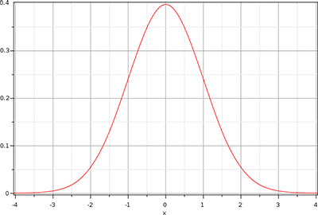

*Fig 13 - Gaussian Blur function*

As the Gaussian curve has a larger area close to its center, using its values as weights to blur an image gives more natural results, the higher values are near the center and fade away with increase of distance. To apply the gaussian blur we choose to use a method called two-pass Gaussian blur that uses a property that transforms the two-dimensional Gaussian equation into two one-dimensional equation, one horizontal and vertical. This technique requires that we blur the image at least two times. To achieve this we will need a pair of framebuffers, one to render to and the other with the texture to draw with, then we alternate between them switching their roles. The more the passes of the blur shader the stronger the bloom effect.

To complete the bloom we need to combine the blurred brightness texture with the original scene texture. To combine we add both texture to blend them together in the final shader. Also in this last shader we did exposure tone mapping with gamma correction to help us balance the colors of our scene.

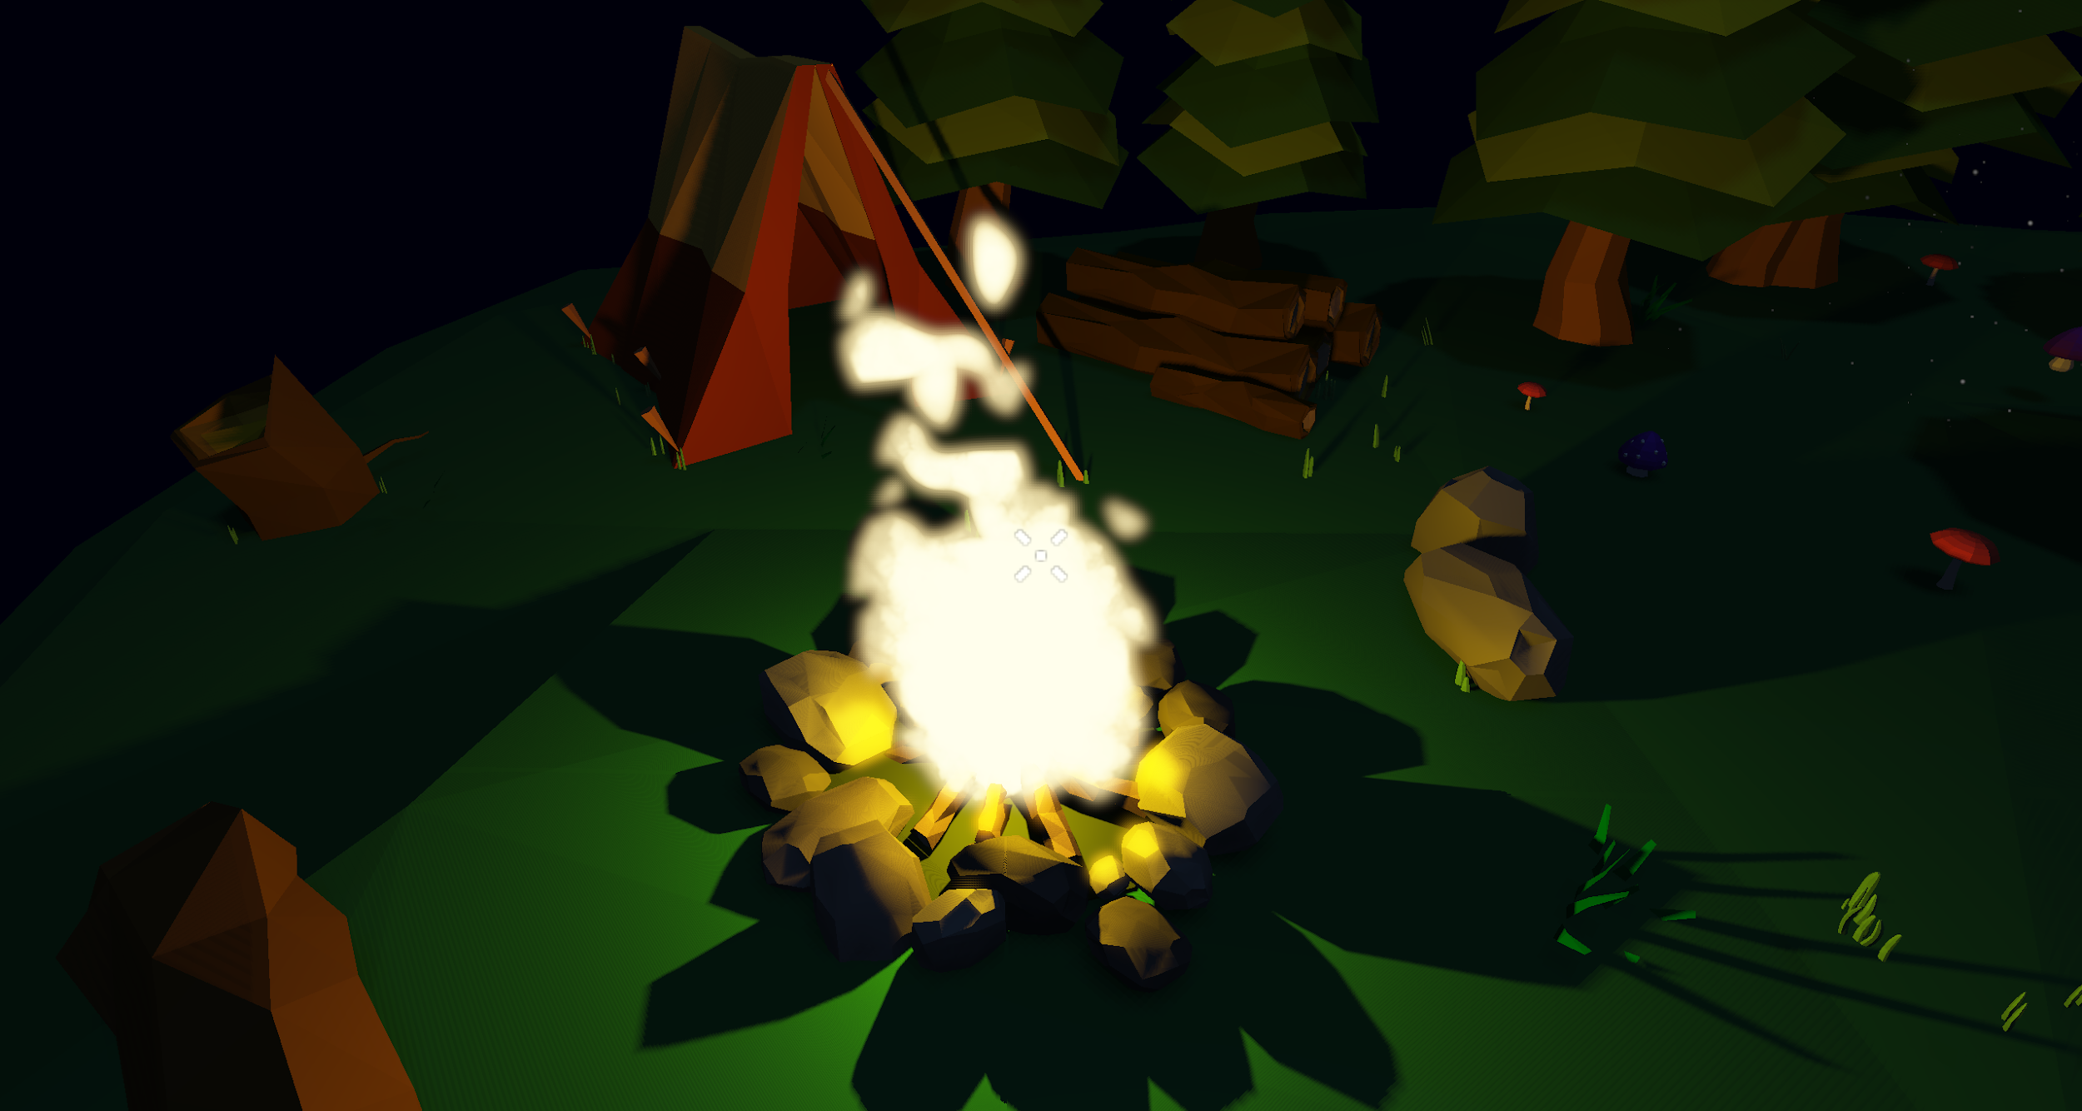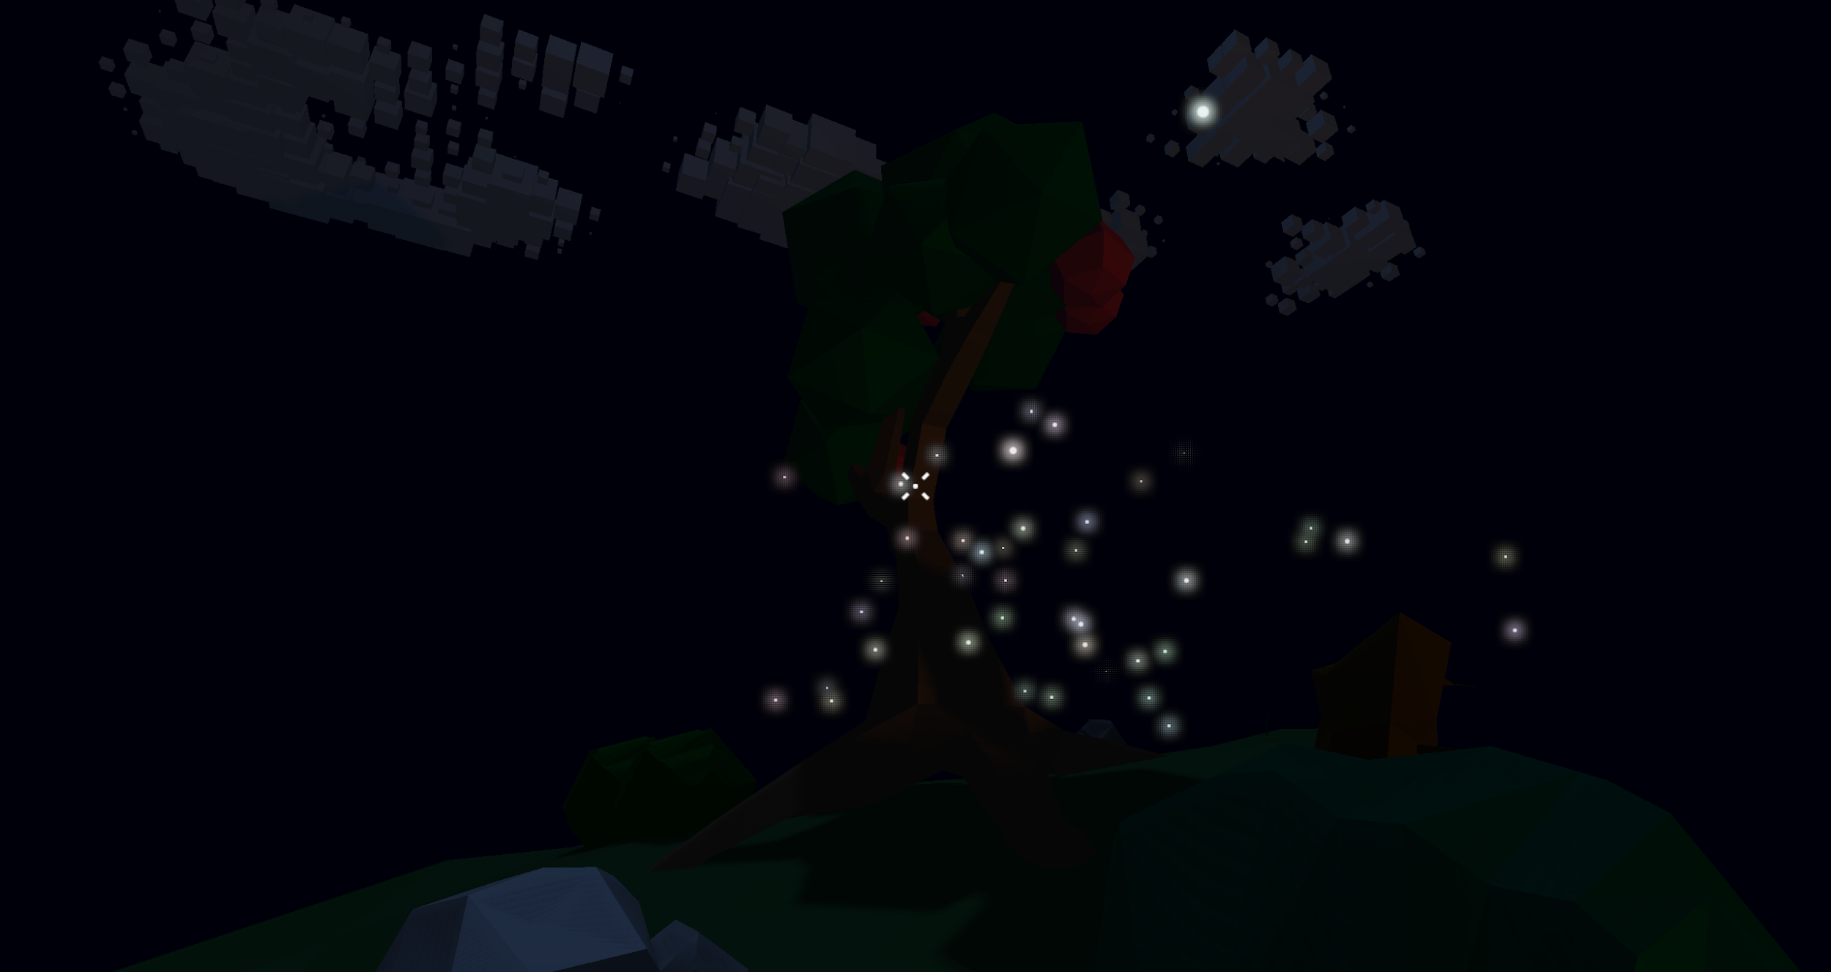

*Fig 14.1/14.2 - Examples of bloom applications: Fireflies and Fire*

* 1. **Stylized Solid Material: Clouds**
     1. Explored approaches

In order for the clouds to be generated with an organic look it required us to implement perlin noise. The perlin noise algorithm may vary in many aspects:

* Gradient function: function responsible for generating pseudo-random values that always provides the same value for a given input independently of the time and number or requests.
* Fade function: function that provides the interpolation curve.

Both functions can have a variety of different implementations.

For the gradient function the original perlin noise uses a constant fixed-length list of random values, to which is then applied a simple hash function to provide the output. Other approaches also use a constant list, but produced and shuffled at runtime. And some use other pseudo-random methods such as combination of periodic wave functions. For the fade function many polynomial functions can be applied.

The generation of the clouds’ mesh itself and the underlying procedural generation algorithm can be done in many ways:

* Choose a center point, generate spherical meshes of varying size in position close to the center using noise, and then apply some jitter and turbulence to the vertices of the spheres.
* Create a 3D virtual grid, use 3D perlin noise to query values corresponding to the cells, use marching cubes algorithm to generate a mesh from the noise, adjust the noise values to create shapes resembling clouds.
* Create a 2D virtual grid, use 2D perlin noise to query values corresponding to the cells, generate cubes in the cells’ positions with size according to the noise value, adjust the noise values to create shapes resembling clouds.

The management of the clouds meshes can also be done in different ways. We could treat the meshes as general scene nodes with their corresponding meshes, and thus the draws calls would be done separately. On the other the clouds could be ‘joined’ inside the clouds system drawn all at once using batch rendering. Or in the case of the third cloud generation algorithm, since all the meshes are cubes with varying sizes and positions, instanced rendering could be used to greatly improve the render time and memory usage.

* + 1. Final Implementation

The implemented approach for cloud generation was the one using individual cube meshes along a 2D grid (third point mentioned above), thus we also needed to implement 2D perlin noise. We chose this implementation because it’s the one that shows the best visual effect when animated moving through the sky and merging with other clouds.

The perlin noise’s chosen implementation uses as gradient function a combination of sine waves:

grad(x, y) = 2920*sin(21942*x + 171324*y + 8912) * cos(x*23157*y*217832 + 9758)

, and as fade function uses the polynomial:

f(a) = a^3 * (a*(6a-15) + 10).

The algorithm itself works by creating small rectangular 2D grids and assigning noise values to the cells.

The cells where the noise value is greater than 0 correspond to a cube that is part of the cloud.

These smaller grids are positioned as part of a much larger grid, corresponding to the entire sky, thus making what will be the entire cloud generation zone.

The create the movement of the clouds at regular timesteps the perlin noise assigned to each cell is shifted to left, and in accomplish a growing/morphing effect each cell has an additional size attribute, starting at 0, and gradually increasing/decreasing until reaching the perlin noise associated with the cell. This creates the effects of the cubes slowly growing in front of the cloud and other fading behind the cloud.

To add a lifetime to each cloud, when created, a lifetime value is assigned to the cells that composed the generated cloud. The lifetime and age of a cell is also shifted when shifting the perlin value along the grid, and when the age reaches the lifetime, the perlin value is set 0, thus making the cloud’s cubes start to shrink until it vanishes completely.

To add more dynamism to the movement we also added turbulence to both the size and position of the cubes. This is accomplished using sine functions and random starting offset values assigned to each cell, that are incremented by delta time when the cloud system updates.

The rendering of the clouds is optimized by using instanced rendering, meaning the cloud system stores the mentioned cell variables, when draw is called a vertex buffer is filled with the position and size of the active cubes, and then the vertex shader uses these values the update the cube vertices. Effectively the OpenGL draw call receives a single cubes mesh and a buffer filled with positions and sizes.

* 1. **Shadows**
     1. Explored approaches

In regard to shadowing, we opted for shadow mapping resorting to depth texture rendering. This seemed to be the more widespread and simple approach in regard to creating shadows. A huge learning source to achieve our results was the website learnopengl.com.

After already having prototyped the shadows, we stumbled upon a bit more complex method that would allow us to create point light shadows more efficiently, but due to time constraints we couldn’t delve too deep into it, and decided to adapt the working solution to a point light.

* + 1. Final implementation

Shadow mapping is based in a simple concept: anything the light sees is lit, and what it doesn’t see is in shadow.

To accomplish this, there are some steps that need to be taken. Let us look at the simpler case of the moon and sun shadows first. In this case, we needed to set up an orthographic camera, because a directional light creates shadows without perspective. This camera should look in the same direction as the lighting direction.

Then, we create a framebuffer, with a texture associated to the depth component. By rendering the scene through the camera previously mentioned, using a simple shader just to make the render.

Now, using this depth texture in the main shader, we can perform the shadow calculation. By using the fragment position in the world space, and multiplying it by the light space matrix, we can obtain the fragment position in the texture. Then, we compare the depth parameter to the depth stored in the loaded shadow map. If the stored depth is the same, then this fragment is being seen by the light camera, and it is in light, otherwise, it is in shadow.

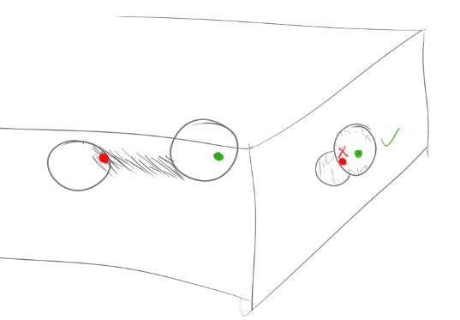

*Fig 15 - Shadow Sketch 1*

This shadow value then is used in the lighting calculation to cancel out the specular and diffuse components, creating the shadows in the scene.

There are some issues that need to be solved in the shadow calculation, for example the shadow artifacts, created due to the way the depths are calculated for each pixel on the texture. A bias needs to be added to the shadow in order to avoid these artifacts, but this bias detaches the shadows from their objects depending on how big it is, so a compromise was needed to be achieved in order to have the scene look at its best.

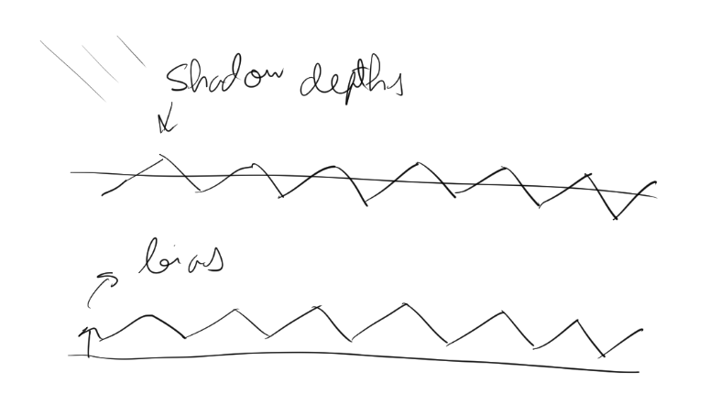

*Fig 16 - Shadow Sketch 2*

A method of smoothing was also used. Putting it simply, it works by looking into the shadow values in the area surrounding the actual fragment, and the shadow value instead of being 0 or 1, ends up being in that range, and affects the lighting calculations accordingly.

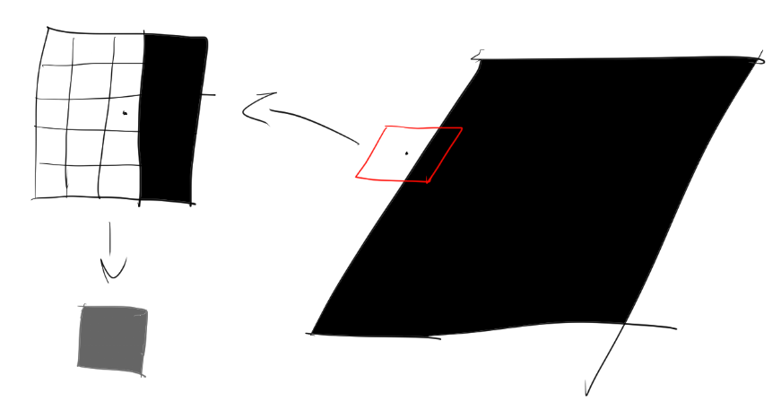

*Fig 17 - Shadow Sketch 3*

The point light shadows were made in a similar way, except using perspective cameras, and having 5, pointing to x+, x-, z+, z- and y-. Each has a FOV of 90º, and an aspect ratio of 1, so they cover their side, and combine to create omnidirectional shadows. Then in the shadow calculation, a selection function is used to see to which shadow map the fragment needs, and the shadow is calculated there.

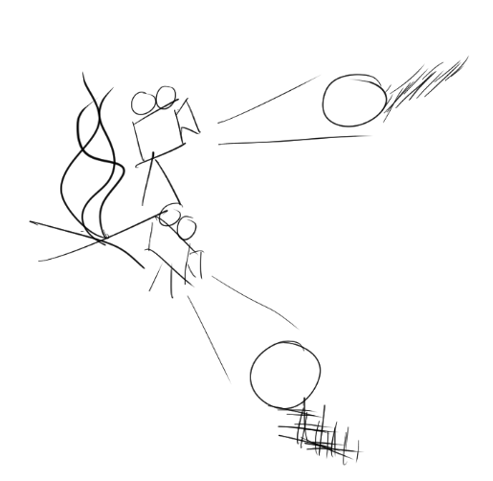

*Fig 18 - Shadow Sketch 4*

A more refined method could be used using cubemaps and geometry shaders to avoid some renders, but the method used allowed the use of the previous shadow class.

The smoothing of the shadow created an issue in the places where the camera views came together, so to avoid this, there is a check to see if smoothing can be applied.

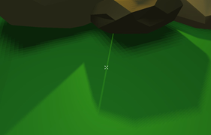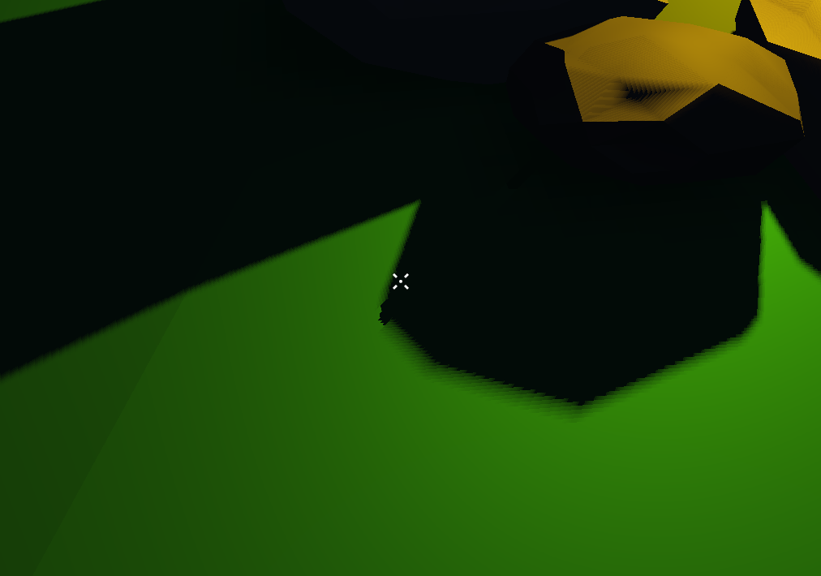

*Fig 19 - Shadow Smoothing Example*

* 1. **Particle System**
     1. Explored approaches

The particles of the particle system may be rendered in different ways, drawn individually, drawn using batch rendering, or drawn using instanced rendering.

To deal with the transparency of the particles when overlapped they can either be sorted using the distance to the camera or drawn with depth writing disabled.

* + 1. Final Implementation

To implement the particle system we started by creating a generic particle emitter class responsible for the general particle methods and operations, as mentioned in section 2.

To improve performance when a particle ‘dies’ it is just marked with negative age instead of being removed from the particle list. Consequent adds of new particles to the list are added in place of these existing ‘zombie’ particles.

Also to improve performance we use instance rendering, meaning the OpenGL draw call receives a single quad a buffer filled with particle size, position, rotations and colors, which are then applied in the shaders.

To avoid sorting the particle we disable depth writing before the draw call so that the transparencies of the particles are drawn correctly.

Both dust and firefly particles are similar, we just tweak the lifetime, size, color, position and speed variables when spawning, updating the particles.

But for the fire to have the desired effect, the fragment shader additional to the texture also receives a texture generated with perlin noise, which is used as a dissolve map for the dissolve effect that is applied to the particles. The shader receives for each particle a factional number that tells the shader the portion of the dissolve map to use, this effectively creates the effect of the particle slowly disintegrating as it rises, creating an effect resembling the traditional hand-animated fire usually seen.

* 1. **Additional Techniques**
     1. HUD Element: Crosshair

The crosshair is drawn as a HUD element, thus it is part of a separate scene drawn after the main scene, and instead of the main camera uses a static orthographic camera facing the xy plane.

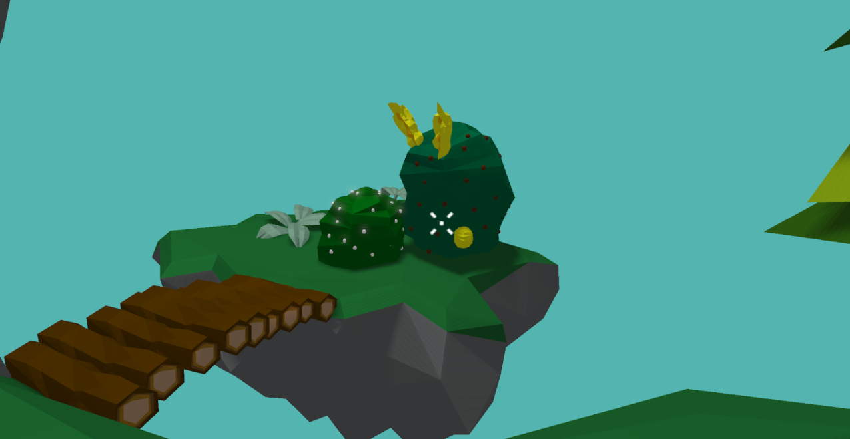

*Fig 20- Crosshair in the middle on the screen*

* + 1. Background

The background plane is a quad positioned in the xy plane and drawn before the main scene with depth writing disabled so that every consequent object is drawn in front of it. In order for it to always fill the window no transformation matrix is applied in the shaders and vertices are set to fill the Normalized Device Coordinates (NDC) space.

* + 1. Scene Modeling

In regards to the modelling of the low-poly forest-themed objects, we opted to use Blender. To simplify the color recognition process we set the name of the different materials to the respective colors’ names in the RGB format. Then the meshes were exported in Wavefront (.obj).

Afterwards, we attempted various dispositions of the scene until we reached the one that pleased us the most.

## **Post-Mortem**

## **What went well?**

We believe our decision of doing a camp scene worked pretty well to showcase the various elements we wanted to create.   
 The campfire is a great example of a point light, and being an outdoor scene we were able to include the directional lighting from the sun as well.

For the clouds we first thought about implementing the marching cubes algorithm, but the initial test with the cubes looked so fitting and showed great promise, so we went with it and it ended up looking great.

The Bloom effect allowed us to portray the brightness that we hoped for which improved the lighting dynamic of the scene a great deal, particularly when set to the night mode. It also allowed us to give more depth to our environment, making it that much more interesting.  
 By being able to interact with the objects, which was made possible by the mouse picking technique developed, a lot of dimension was added to the scene, as the barrier between the image and the user was broken down and the sense of reality was therefore improved.

## **What did not go so well?**

Regarding shadowing, we later found a more efficient method for the point light shadows, a method that would use geometry shaders to render the whole scene surrounding the light in a single shader pass, and test the depth using a cube map, but due to time constraints we were not able to put it in practice. We adapted our approach and ran into some issues like the previously mentioned smoothing between camera views, but we ended up using some workarounds that don’t impact too much on the visual aspect of the scene.  
 When it came to the development of the Bloom effect, we really were not expecting the various layers we encountered in the implementation, from the post-processing to the HDR and then the Bloom. This along with some issues regarding the particularities of the binding to multisampled framebuffers which we had not foreseen, ended up being a problem that slowed us down, however that we successfully overcame.

## **Lessons learned**

While joining the different parts of the project, we ran into some unfortunate issues and bugs. If we were aware of the time it would take to get everything together we would probably have done it sooner as a project with this dimension really is very dependent on every aspect being developed.   
 Now that we are aware of the challenges and the process to overcome them, we could probably create a much better schedule to guide us, which would be more mindful of the issues we had not yet predicted.

## **Acknowledgments**

We wish to thank Professor Carlos Martinho for his detailed classes on the various OpenGL techniques as well as Professor Samuel Gomes for his assistance in our implementation.

## **References**

Mouse-Picking:

<https://antongerdelan.net/opengl/raycasting.html>

<https://learnopengl.com/Advanced-OpenGL/Stencil-testing>

<https://www.youtube.com/watch?v=LyoSSoYyfVU&t=223s>

Blinn-Phong:

<https://learnopengl.com/Advanced-Lighting/Advanced-Lighting>

Bloom:   
<https://learnopengl.com/In-Practice/2D-Game/Postprocessing>

<https://learnopengl.com/Advanced-OpenGL/Framebuffers>

<https://learnopengl.com/Advanced-Lighting/Bloom>

<https://learnopengl.com/Advanced-Lighting/HDR>

Clouds:

<https://www.youtube.com/watch?v=RCfBtN5ZAtA&ab_channel=KyleAndrews>

<https://en.wikipedia.org/wiki/Perlin_noise>

Shadows:   
<https://learnopengl.com/Advanced-Lighting/Shadows/Shadow-Mapping>  
Particle System:

<http://www.opengl-tutorial.org/intermediate-tutorials/billboards-particles/particles-instancing/>

<http://www.opengl-tutorial.org/intermediate-tutorials/billboards-particles/billboards/>

<https://www.artstation.com/artwork/4nGAW>